**Lab 5 Ex 1**

**Loan origination – Data Engineering for Financial Service Marketing**

Create a program that produces a .csv file of customers based on demographic characteristics defined by the user.

Provide a 10 row head of the new data frame.

Provide a histogram of the credit score of the customers with the new data frame.

The program must allow for segmentation on multiple variables

Write the marketing list to a .csv file.

**Example output:** A bank in the Twin Cities wants to target customers for student loan consolidation. Create a list of customers from Minnesota who have an active loan, are 30 years of age or younger with a with a household income of over $3000 a month.

Lab 5 Ex 1 Input

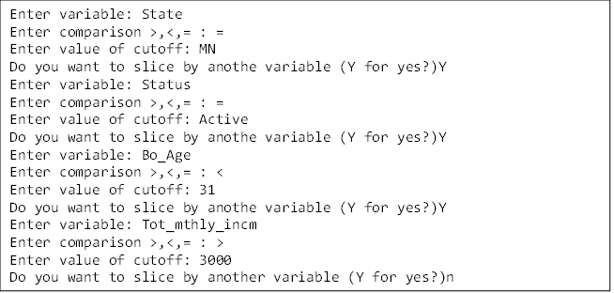

Enter variable: State

Enter comparison >,<,=: =

Enter value of cutoff: MN

Do you want to slice by another variable (Y for yes?): Yes

Enter variable: Status

Enter comparison >,<,=: =

Enter value of cutoff: Active

Do you want to slice by another variable (Y for yes?): Y

Enter variable: Bo_Age

Enter comparison >,<,=: <

Enter value of cutoff: 31

Do you want to slice by another variable (Y for yes?): Y

Enter variable: Tot_mthly_incm

Enter comparison >,<,=: >

Enter value of cutoff: 3000

Do you want to slice by another variable (Y for yes?): N

Lab 5 Ex 1 Output ###note format may be slightly different and is not graded on this exercise.

